Workshop on
Collective Agency & Institutions, Sustainability, and the Capability Approach
(26th,) 27th and 28th of September 2012, UFZ, Leipzig, Germany

Wed, 26.9. |  | responsible
19:00- | Dinner in city centre for early comers (pay your own)
Thu, 27.9. | Opening up the discussion (lecture hall, building 1.0, 1st floor)
09:00-09:30 | Presentation round | all
09:30-10:00 | Presentation of GeNECA: Sustainable development and capability approach (project description and narrative) | Felix
10:00-10:30 | Why collective agency and institutions? | Ortrud
10:30-11:00 | Discussion
11:00-11:30 | break
11:30-12:00 | Interventions by Jürgen Volkert, Ines Omann, Peter Krause
12:00-12:30 | Discussion
12:30-13:30 | Lunch break
13:30-14:00 | Interventions by Torsten Masson, Rebecca Gutwald, Felix Rauschmayer
14:00-14:30 | Discussion
14:30-15:30 | Identification of specific points of interest and 3 breakout groups – reporting on flip charts | Felix
15:30-16:00 | Break around the flip charts
16:00-17:30 | Christoph Görg (UFZ) on global processes, the limits of individualistic methods in analysing sustainable development and procedural justice
19:00- | Dinner in a regenerating city quarter (Café Schwartz)

Fr, 28.9. | Closing down the discussion (lecture hall, building 1.0, 1st floor)
9:00-10:30 | David Schweikard (University of Münster, Germany) on the structure and politics of group agency with regard to sustainable development
10:30-11:00 | break
11:00-12:30 | Solava Ibrahim (University of Manchester, UK) on collective agency in the Capability Approach and the links between sustainable and human development
12:30-13:30 | Lunch break
13:30-15:00 | 3 breakout groups with 3 paper inputs à 5 min + 1 discussant à 10 min.; discussion; first conclusion
1: social practice and motivation for SD |  | 2: individual responsibility | 3: linking the economic and civil realm - the role of trust
Lieske Voget: Employing the Capability Approach (CA) in assigning individual responsibility for collective sustainable development (SD) |  | Peter Krause: Measures of individual and collective capabilities (CA) with regards to sustainable development (SD) - Concepts and first empirical applications – | Ines Omann: Can Community Currencies increase Capability Sets for Sustainable Lifestyles
Gordon Walker: Inequalities and sustainable social practices: locating justice in capabilities |  | Wouter Peeters: Sustainable Human Development, capabilities and responsibilities | Jürgen Volkert: Agency and Corporate Impacts on Sustainable Human Development (SHD)
Felix Rauschmayer: A nature-related conflict from a capability perspective |  | Tuuli Hirvilammi: how to restrict the natural resource use of individuals without contradicting their well-being freedom? | Dorothea Kleine: Sustainable Public Procurement: a test case for CA and Sustainability thinking
Discussant: Martin Rechenauer (tbc) |  | Discussant: Ortrud Lessmann (tbc) | Discussant: Tullia Jack (tbc)
15:00-16:00 | Presentation of breakout group results; Discussion;  Summing up of the workshop |  |  | Felix

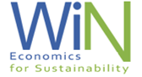
GeNECA is a 3 years research project (04/2010-05/2013) funded by the German Federal Ministry of Education and Research as part of the funding programme "Economics for Sustainability". (FKZ 01UN1015A, www.wi-n.org)
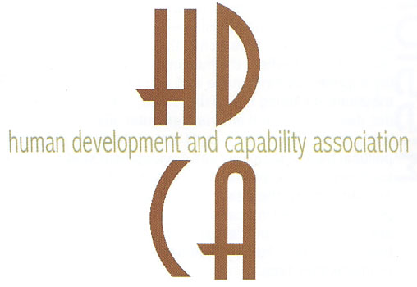

This workshop is also an activity of the Thematic Working Group “Sustainability” of the Human Development and Capability Association.

